Mixtures and Pure Substances

Matter can be classified into two groups: mixtures and pure substances. Mixtures are the most common form of matter and consist of mixtures of pure substances.
They can be homogeneous mixtures (uniformly mixed) or heterogeneous mixtures (not uniformly mixed). Mixtures can be separated using physical processes that do not involve the changing of the nature of the pure substances that are in the mixture. Pure substances can either be compounds (combinations of more than one type of element) or elements. The elements in compounds can only be separated by chemical processes that change the nature of the pure substance. In turn, elements can combine to form compounds through a chemical process that changes their nature. Below is a chart summarizing this classification of matter.
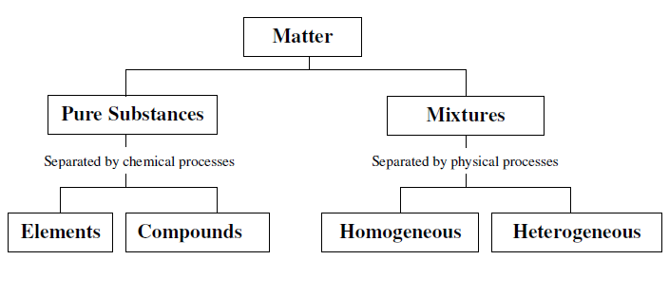
In this unit we will explore the general properties of matter including separation methods and classification techniques. In doing so, we will use some new lab equipment.

Pre-lab:
Match the following with their proper classification by writing the letter of the
correct match in the space provided.
_____Orange Juice
_____ Apple Juice A. Element
_____ Granite Rock B. Compound
_____ Milk C. Homogeneous Mixture
_____ Salt Water D. Heterogeneous Mixture
_____ Carbon Dioxide
_____ Oxygen
_____ Air
_____ Water

Research and give three examples of chemical separation processes.

Research and give three examples of physical separation processes and indicate on what physical constant the separation is based. (e.g. distillation of a liquid mixture is based on the difference in boiling points of each component in the mixture).

Post-Lab Report

Part A: Pure Substances-Element to Compound
Observations:

1. What is the chemical process used in this experiment?

2. What is the white compound formed in this experiment?

3. What happens to the white compound when the acid is added? What does it form?

Part B: Pure Substance-Compound to Element
Observations:

1. What is the reactant that is changed in this experiment?

2. What is the product formed?

3. What is the chemical process used to form the element?

Part C: Mixtures-Homogeneous
Observations:

1. What is/are the pure substance(s) used to make the homogeneous mixture?

2. What are the pure substances formed at the end of the experiment?

3. What is the process used in this experiment and what kind of process is it?

Part D: Mixtures-Heterogeneous
Observations:

1. What would be your guess as to the composition of the dark colored portion of the mixture?

