Atomic Basics Name ___________________________
Part A: Atomic Structure
- Place five protons (blue marbles) in the nucleus of the atom.
- Place six neutrons (red marbles) in the nucleus of the atom.
- Place two electrons in the first energy level.
- Place three electrons in the second energy level
- What element is represented by the atom board?

Part B: Atomic Calculations
6. Label the information provided in the periodic table.

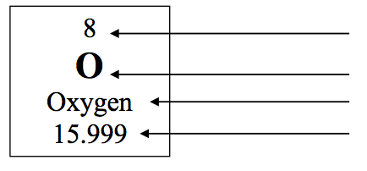7. What does the atomic number represent? ____________________ or ____________________
8. What does the atomic mass represent? ____________________ + ____________________

9. How would you figure the number of protons or electrons in an atom?
10. How would you figure the number of neutrons in an atom?
11. Use your knowledge of atomic calculations to complete the chart.
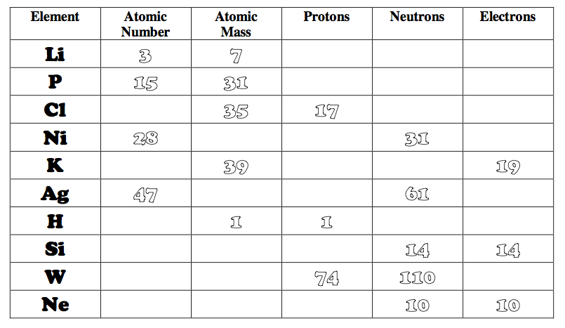
Part C: Electron Configuration
12. Look at your atom board. How many electrons can each level hold?
1st = _____ 2nd = _____ 3rd = _____
13. What term is used for the electrons in the outermost shell or energy level? ____________________
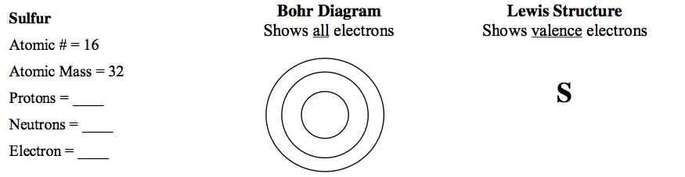
14. Scientists use two types of diagrams to show the electron configuration for atoms.

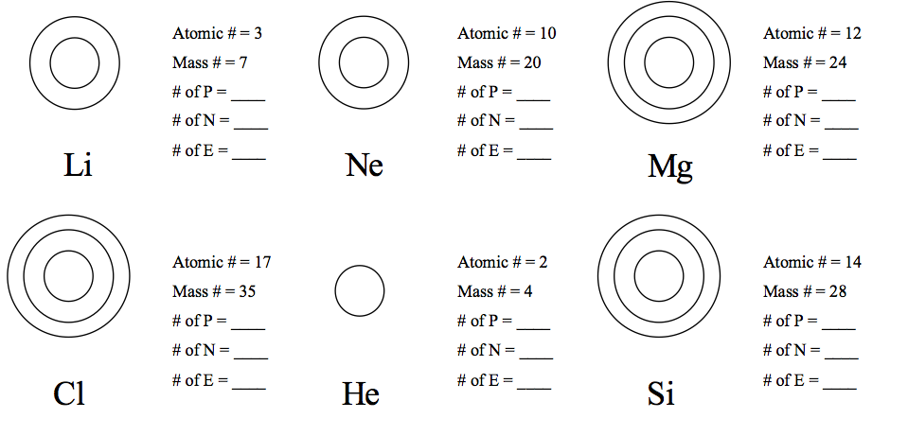
15. Calculate the missing information and then draw the Bohr Diagram and Lewis Structure for each element.

16. Answer the questions below based on the elements in question #15.
(1) Which elements had a filled outermost shell? _____ _____
(2) Which element would be most likely to lose electrons in a chemical bond? _____
(3) Which element would be most likely to gain electrons in a chemical bond? _____
(4) Which elements are not likely to bond with other elements? _________
Why? _________________________

