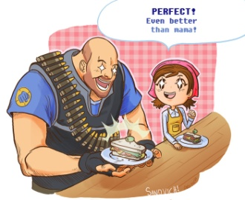**Basic Stoichiometry PhET Lab**

*Let's make some sandviches!*

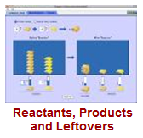

**Introduction:**

When we bake/cook something, we use a specific amount of each ingredient. Imagine if you made a batch of cookies and used way too many eggs, or not enough sugar. YUCK! In chemistry, reactions proceed with very specific recipes. The study of these recipes is *stoichiometry*. When the reactants are present in the correct amounts, the reaction will produce products. What happens if there are more or less of some of the reactants present?

**Vocabulary:** Before you begin, please define the following:

Limiting Reactant: ______________________________________________________________________

Excess Reactant: ______________________________________________________________________

Synthesis Reaction: ______________________________________________________________________

Combustion Reaction: ______________________________________________________________________

Mole Ratio: ______________________________________________________________________

Diatomic Molecule: ______________________________________________________________________

Mole: ______________________________________________________________________

Hydrocarbon: ______________________________________________________________________

**Part 1: Making Sandviches:** 

1. The  is a simulation of a two-reactant *synthesis* reaction. In this case, one reactant will be *limiting*, while the other will be in excess.
2. Take some time and familiarize yourself with the simulation.
3. Set the reaction to a simple mole ratio of 2:1:1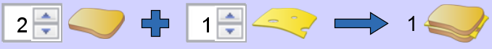
4. Complete the table below while making tasty cheese sandwiches:

|  |  |  |  |  |
| --- | --- | --- | --- | --- |
| Bread Used | Cheese Used | Sandwiches Made | Excess Bread | Excess Cheese |
| 5 slices | 5 slices |  |  |  |
| 4 slices | 3slices |  |  |  |
|  |  | 2 sandwiches | 1 slice | 0 slices |
| 6 slices |  | 3 sandwiches |  | 4 slices |

**Part 2: Real Chemical Reactions:** 

1. 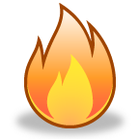Now let's work with real chemical reaction, one that creates a very entertaining BOOM!
2. What is the mole ratio for the reaction of hydrogen and oxygen to produce water?



1. Complete the table below while making water H2O from hydrogen H2 and oxygen O2:

|  |  |  |  |  |
| --- | --- | --- | --- | --- |
| Hydrogen Molecules H2 | Oxygen Molecules O2 | Water Molecules H2O | Excess H2 | Excess O2 |
| 4 molecules | 4 molecules |  |  |  |
| 7 molecules | 6 molecules |  |  |  |
|  |  | 4 molecules | 0 molecules | 0 molecules |
| 9 moles | 8 moles |  |  |  |
|  |  | 4 moles | 1 moles | 0 moles |
| 4.0 moles | 2.5 moles |  |  |  |
| 1.5 moles |  | 1.5 moles | 0 moles | 0 moles |

1. MC900417464[1]Notice that the labels changed from **molecules** to **moles**. This does not change the mole ratio, as a mole is simply a large number of molecules. How many molecules is a mole? _________________
2. Now try producing **ammonia**, a very important chemical in industry and farming.
3. What is the mole ratio for the production of ammonia? 
4. Complete the table below:

|  |  |  |  |  |
| --- | --- | --- | --- | --- |
| Moles N2 | Moles H2 | Moles NH3 | Excess N2 | Excess H2 |
| 3 moles | 6 moles |  |  |  |
| 6 moles | 3 moles |  |  |  |
|  |  | 4 moles | 2 moles | 0 moles |
| 1.5 moles | 4.0 moles |  |  |  |

1. Combustion of **hydrocarbons** like methane CH4 produces two products, water and carbon dioxide CO2.
2. What is the mole ratio for the combustion of methane? 
3. Complete the table below: **WATCH FOR FRACTIONS**

|  |  |  |  |  |  |
| --- | --- | --- | --- | --- | --- |
| mol CH4 | mol O2 | mol CO2 | mol H2O | Excess mol CH4 | Excess mol O2 |
| 4 mol | 4 mol |  |  |  |  |
| 3 mol | 6 mol |  |  |  |  |
|  |  | 2 mol | 4 mol |  |  |
|  |  | 3 mol |  |  |  |