Lab Expectations‬
Labs must fulfill the following to be considered complete:
- All Lab Safety Rules must be followed at all times during all labs.
- Each lab must have its own page in your website
- Linked files are not acceptable. Math calculations and graphs (if applicable) must be imbedded in your page.
- Do not include the original lab sheet in your lab write up
- For grading guidelines, see Lab Rubric
- The following sections will be included.

Title
Abstract:
The abstract presents a synopsis of the experiment. The abstract should be written concisely in normal English. The author should assume that the reader has some knowledge of the subject but has not read the paper. Thus, the abstract should be intelligible and complete in itself; particularly it should NOT cite figures, table or sections of the paper. The opening sentence or two should, in general, indicate the subjects dealt with in the paper and should state the objectives of the investigation.

The body of the abstract should indicate newly observed facts and the conclusions of the experiment or argument discussed in the paper. Attention should be drawn to the nature of the data collected in the paper. For experimental results, the abstract should indicate the methods (procedure synopsis) used in obtaining the data and the degree of accuracy should be given. The abstract should be typed as one paragraph with an optimum length should not exceed 200 words.

Introduction
The "Introduction" of a laboratory report identifies the experiment to be undertaken, the objectives of the experiment, the importance of the experiment, and overall background for understanding the experiment. The objectives of the experiment are important to state because these objectives are usually analyzed in the conclusion to determine whether the experiment succeeded. The background often includes theoretical predictions for what the results should be.

Procedure
The "Procedures," often called the "Methods," discusses how the experiment occurred. Documenting the procedures of your laboratory experiment is important not only so that others can repeat your results but also so that you can replicate the work later, if the need arises. Historically, laboratory procedures have been written as first-person narratives as opposed to second-person sets of instructions. Because your audience expects you to write the procedures as a narrative, you should do so.
Achieving a proper depth in laboratory procedures is challenging. In general, you should give the audience enough information that they could replicate your results. For that reason, you should include those details that affect the outcome. Consider as an example the procedure for determining the density of a metal cylinder. Mass determinations of the object are necessary and often use an electronic balance. Electronic balances require calibration and these calibrations are considered standard so therefore not needed to be reflected in your procedure. What you would want to include, then, would be those details that might cause your results to differ from those of your audience. Such details would include the model number of the electronic balance and the ambient temperature where the electronic balanced was used.
Results
The heart of a laboratory report is the presentation of the results. Along with the raw data collected in the lab, pay attention to the errors that existed in the experiment, both where they originated and what their significance is for interpreting the reliability of conclusions. One important way to present numerical results is to show them data tables. If the results are intended to show a trend or pattern, then showing them in a graph is necessary.
Conclusion
The "Conclusion" section discusses the results in the context of the entire experiment. Usually, the objectives mentioned in the "Introduction" are examined to determine whether the experiment succeeded. If the objectives were not met, you should analyze why the results were not as predicted.

See the lab example below
**Note: The experiment below is completely fictitious, it was generated for example purposes only**

Effects of Food Availability on Obesity in Golden Retrievers

Abstract:

This report deals with the effects of calorie consumption on obesity in Canis lupus familiaris, specifically, the golden retriever breed. The study encompassed a population of one hundred animals that were divided into ten study groups. These groups were given increasing amounts of Blue Buffalo Life Protections Healthy Weight Chicken and Brown Rice Recipe for Adult Dogs dog food starting with the first test group getting 75% of the recommended amount of 2 1/4 cups/day and increasing by 1/4 cup for each test group. The expectations for this experiment is the mass of the animals will directly correlate to the amount of food given. A direct relationship between the daily caloric intact and body mass is expected. A daily routine of feeding one-half the daily intake in the morning followed by a one hour period of exercise and then allowing for uninhibited indoor activity will be followed for the length of the experiment. The second half of the daily food intake will be given in the evening and followed by whatever spontaneous activity the animal prefer before bedtime. Both qualitative and quantitative observations were made throughout the experiment and calculations confirmed the initial expectation of weight gain. The qualitative data showed a significant increase in physical activity, as well as, an increase in behavior issues with higher caloric intake.

Introduction:
Obesity in dogs results in health issues including diabetes mellitus, joint damage, heart disease, breathing difficulties, increased risk of cancer and decreased life expectancy. Family budgets are expected to shoulder the costs of treating these ailments. According to Petplan USA, the costs of treating diabetes mellitus can exceed $900/yr while cancer, joint damage and heart disease can cost in the thousands. These costs are minor compared to the heartache felt by the family when their beloved pet dies prematurely due to obesity. Blue Buffalo brand pet foods are designed to provide all necessary dietary elements for healthy pets (Table 1), but at 415 kcal/cup, too much could present a huge caloric load which would lead to obesity. The purpose of this investigation is to determine how quickly incorrect feeding can adversely affect the health of your pet. The average mass for golden retrievers is between 27-36 kg or 60-80 lbs. Using Table 2, the appropriate amount of food is 2.5 to 3.25 cups/day with the control value of this experiment set to 2.75 cups/day. Theoretically, the mass of the dog should increase with increased food intake but this relationship could be influenced by factors such as activity level, attention issues, genetics and training.

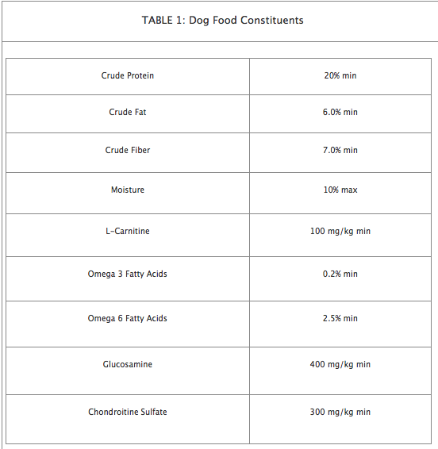
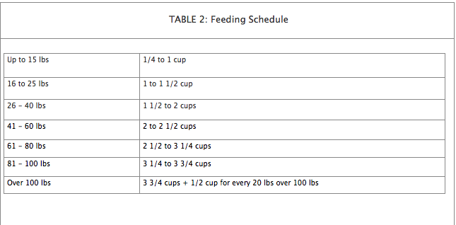

Procedure:
Type procedure here

Results:

Table 3:
Cups Given | Average Dog Mass (kg) |  | Cups Given | Average Dog Mass (kg)
2.25 | 15.43 |  | 3.5 | 43.12
2.5 | 25.72 |  | 3.75 | 52.90
2.75 | 31.12 |  | 4.0 | 60.56
3.0 | 33.94 |  | 4.25 | 71.58
3.25 | 36.78 |  | 4.5 | 92

Conclusion:
Type conclusion here

