Matter Review Packet

1. A mixture (is/is not) a chemical combining of substances.

2. In a compound the (atoms/molecules) are (chemically/physically) combined so that the elements that make up the compound (retain/lose) their identities and (do/do not) take on a new set of properties.

3. The smallest identifiable unit of a compound is a(n) , which is made up of which are chemically bonded.

4. True or False: A mixture is always made up of a combination of elements.

5. In a mixture, the substances (lose/retain) their identities.

6. In a mixture the substances involved (can/cannot) be separated by a simple physical process.
In a compound the elements involved (can/cannot) be separated by a simple physical process because the elements are (physically combined/chemically bonded).

7. True or False: An element can be broken down into a simpler substance.

8. The smallest identifiable unit of an element is a(n) .

9. From the following list of substances, circle the ones that are elements:
silver | carbon dioxide | wood alcohol | chromium
water | hydrogen | carbon | nitrogen
oxygen | gold | sugar | salt
air | sulfur | magnesium | nickel

10. Explain how to separate the sugar and water in a solution of sugar and water.

11. How would you separate a mixture of alcohol and water?

12. How would you separate sand and water?

13. Classify the following as pure substances or as mixtures:

air | gasoline | grain alcohol
water | sugar | gold
mercury | oxygen | salt water

14. Classify the following as heterogeneous or as homogeneous:

sand & salt mixture | hydrogen | iron
salt water | unfiltered air | iron with rust
pure water | an apple | nitric acid
tossed salad | granite | wood

15. Classify the following as an element, a compound, a solution, or a heterogeneous mixture:

aluminum raisin bread carbon dioxide water
sugar and water sulfur sulfuric acid mercury
an orange water & instant coffee

a pencil carbon particles & sugar nitrogen air
gasoline grain alcohol

Elements, Compounds, and Mixtures
Classify each of the pictures below by placing the correct label in the blanks below:
A= Element D= Mixture of compounds
B= Compound E= Mixture of elements and compounds
C= Mixture of elements

Each circle represents an atom and each different color represents a different kind of atom. If two atoms are touching then they are bonded together.

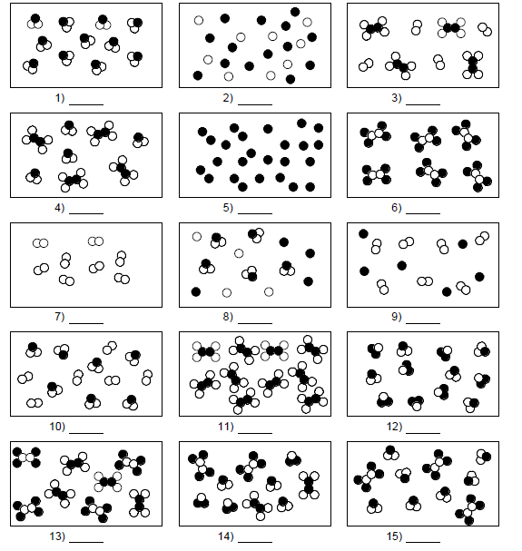

Place a check in the appropriate column:
Change | Physical  Change | Chemical  Change
Salt dissolves in water.
Hydrochloric acid reacts with magnesium to produce hydrogen gas.
A piece of copper is cut in half.
A sugar cube is ground up.
Water is heated and changed to steam.
Iron rusts.
Ethyl alcohol evaporates.
Ice melts.
Milk sours (goes bad).
Sugar dissolves in water.
Sodium and potassium react violently with water.
Pancakes cook on a griddle.
Grass grows on a lawn.
A tire is inflated with air.
Food is digested in the stomach.
Water is absorbed by a paper towel.
Ethyl alcohol boils at 79°C.
Paper burns.
Water freezes at 0°C.
Fireworks explode.
Alka-Seltzer gives off carbon dioxide when added to water.
Clouds form in the sky.

INSTRUCTIONS: Write E in the blank if the material is heterogeneous or O if it is homogeneous.

1. Wood 6. Dirt

2. Freshly-brewed black coffee _______ 7. Sausage-and-mushroom pizza _______

3. Water 8. Air

4. Lucky Charms® 9. Milk

5. Salt 10. Gold

INSTRUCTIONS: Classify each of the following as an element [E], a compound [C], or a mixture [M].

11. Gold 16. Air

12. Water 17. Carbon dioxide

13. Seawater 18. Silver

14. Sugar 19. Ice

15. A chocolate sundae 20. A Big Mac®

INSTRUCTIONS: Classify each of the following properties of matter as physical [P] or chemical [C].

21. Color 26. Reacts violently with chlorine _______

22. Density 27. Good conductor of heat _______

23. Burns easily (flammable) 28. Dissolves readily in water _______

24. Not affected by acids 29. Melts at 145 °C

25. Boils at 450 °C 30. Malleable

INSTRUCTIONS: Classify each of the following changes in matter as physical [P] or chemical [C].

31. Grinding chalk into powder 36. Burning gasoline

32. Dissolving salt in water 37. Hammering gold into foil _______

33. Dissolving zinc in acid 38. Melting ice

34. Tearing a piece of paper 39. Digesting food

35. Stretching copper into wire 40. Making hydrogen from water _______

INSTRUCTIONS: Classify each of the following as an intensive property [I] or an extensive property [E].

41. Mass 46. Color

42. Density 47. Volume

43. Melting point 48. Length

