Name_____________________________________
MOLE LAB
*A mole of any substance contains____________________ particles.
*A mole of lead will be heavier or lighter than a mole of oxygen because
________________________________________________________.
*The mass of a mole of a substance can be found using the
__________________________________________ of the substance.
*The units of molar mass are __________________________________.

Procedure Part 1: Sugar in gum
- Find the mass of a piece of gum (in wrapper) before chewing.
- Chew the gum for 5 minutes.
- Find the mass of the gum (on the wrapper) after chewing.
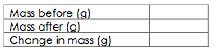
- Throw the gum in the trash.
- Why was there a change in mass?

- The sugar has a chemical formula of C6H12O6. Calculate the molar mass (g/mol).
- Calculate the number of moles of sugar you consumed while chewing the gum.
- Calculate the number of molecules of sugar you consumed while chewing the gum.

Procedure Part 2: Burning a candle
- Find the before mass of a candle.
- Light the candle and allow it to burn for 5 minutes. Do not play with the wax!
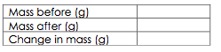
- Without losing any of the wax, re-mass the candle.
Wax is a mixture of different hydrocarbons. We will assume the chemical formula for wax is C25H52.
- Find the molar mass. (g/mol)
- How many atoms of C are in one molecule of wax? __________
- How many atoms of H are in one molecule of wax? __________
- What % of the molar mass is Carbon? (total mass of C/molar mass) x 100%

- How many grams of Carbon would have been in the candle before burning?
- How many moles of wax were used up during burning?

Procedure Part 3: Molecules in your name
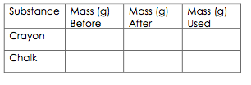
- Find the mass of a crayon.
- Write your full name on a piece of paper.
- Find the mass of the crayon again.
- Repeat steps #1-3 with the chalk.
- Find the molar mass of the crayon. (Made of wax- C25H52)
- How many moles of wax were in your name?
- How many molecules of wax were in your name?
- Find the molar mass of the chalk. (CaSO4) (Did you know chalk isn’t made from chalk anymore!!!)
- How many moles of chalk were in your name?
- How many molecules of chalk were in your name?
- You should have used approximately the same mass of crayon and chalk when writing your name. Why were there LESS molecules of chalk used than crayon?

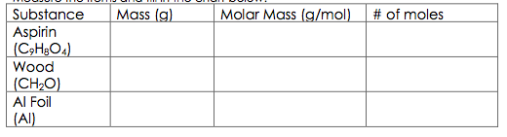
Procedure Part 4:
Measure the items and fill in the chart below.

1. A substance has a mass of 90.1 grams and contains 3.0 x 1023 molecules. Which of the 3 substances in the chart above is it? (Solve for moles first using the molecules given, then set up a ratio to find g in 1 mole.)

