Know the definitions for the following:
Solvent – liquid (usually water) that dissolves the solute to make the solution Solute – solid (usually) that is added to solute and dissolves to make solution Solution – homogeneous mixture of solvent and solute
Concentration – a measure of how much solute per volume of solvent
Molarity – concentration; moles of solute/liters of solvent
Arrhenius Acid and Base – acid donates H+ and base doneates OH-
Bronsted Lowry Acid and Base – acid donates H+ and a base accepts H+
Neutralization – acid + base salt + water
Titration – process used to determine concentration of an acid using neutralization
Solutions/Solubility:
What factors will increase the rate of solubility? Increasing temperature; breaking into pieces; stirring
Calculating Concentration (M = moles/liters)
What is the molarity of 50 grams of NaCl in a 100ml of water?
Convert grams moles: 50 grams NaCl / 58.5 grams (from periodic table) = .85 moles Divide moles by volume .85 moles / 0.1 L = 8.5 M
Dilutions (M₁V₁ = M₂V₂)
If I have 500 mL of a 0.5M NaCl solution, what will the concentration be if the final volume of the solution is 600 mL? (500ml)*(0.5M) = (600ml)( ? M) = 0.42 M
How many liters of 0.5M HCl stock solution would you need to prepare 2 liters of 0.25 M HCl solution? (2 L)*(0.25 M) = (? L) * (0.5 M) = 1 M

Acids and Bases:
Know the properties of acids and bases:
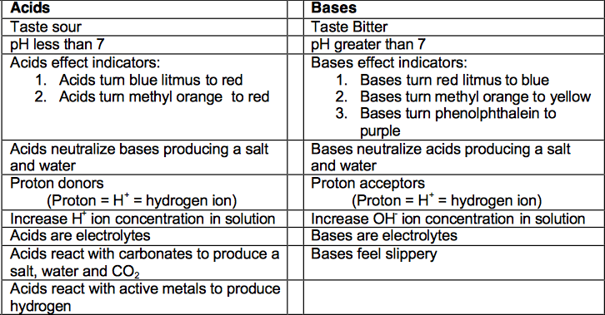
- Write definitions for, or explain the meaning of: Bronsted-Lowry acid and base, neutral, strong acid, strong base, weak acid, weak base, concentrated, dilute, ionization, dissociation
- Know general acid base reactions:
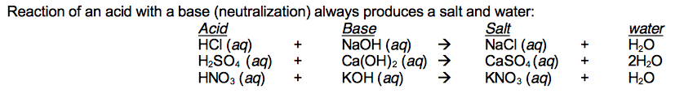

- Be able to recognize acids, bases and salts from their chemical formulas.
- What number do you get when you add up the pH and pOH of a solution?
pH + pOH = 14
- What is pH?
pH is a numerical scale used to express the acidity of a solution.
- What is the range of pH for an acid? For a base? For a neutral compound?
0-7 is acidic, 7 is neutral, 7-14 is basic
- What happens to pH of a solution as you increase the hydroxide (OH-) ion concentration?
As you increase OH- concentration, the pH of a solution will increase.
- What happens to the pH of a solution as you increase the hydronium (H+) ion concentration?
As you increase the H+ concentration of a solution, the pH will decrease.
- Classify the following solutions from most acidic to lease acidic based on their pH and then classify the solutions as most basic to most acidic based on their pH:
Most acidic to most basic: 2, 5, 8, 10, 13
Most basic to most acidic: 13, 10, 8, 5, 2
- What do you use litmus (pH paper) for? If it turns red, what does it indicate about a solution? If it turns blue, what does it indicate about a solution?
You use litmus paper to measure the pH of solutions. If the litmus paper turns red it indicates it is a very acidic solution. If it turns blue, it indicates it is a very basic solution.
- What is phenolphthalein used for? If you add phenolphthalein to a solution and it turns pink, what does that tell you? If it stays clear, what does that tell you?
Phenolphthalein is used to indicate whether a solution is acidic or basic. If you add a drop of phenolphthalein to a solution and it turns pink, it is basic. If you add a drop of phenolphthalein and it remains clear, it is acidic.
- What is the formula we use to determine concentration of a solution?
Molarity = Mol
L
- If you mix 3.4 mol of HCl with 4.6 L of water, what is the concentration of the solution? What is the pH? pOH?
pH= 0.13 pOH =13.87
- If you mix 1.48 mol of HF with 7.8 L of water, what is the concentration of the solution? What is the pH? pOH?
pH = 0.72 pOH = 13.28
- If you mix 2.1 mol of NaOH with 5.6 L of water, what is the concentration of the solution? What is the pH of the solution? pOH?
pOH = 0.43 pH = 13.57 (Remember, NaOH is a base.)

