Lab: How do air bags save lives?
Introduction
In groups of no more than 2 you will be acting as chemists and engineers as a part of an air bag company to design an air bag that will protect a passenger (an egg) from a drop of 1 meter. Your company will need to stoichiometrically calculate the best quantities needed for this reaction. Your company will be working on a strict budget for supplies and the car company (Mrs. Slavens) that you are selling your product to will take both success and expenses into consideration for selecting the final company that the air bags will be purchased from. In other words, you are competing against the other companies (your classmates) for the car company’s bid!
Background information
The development of the air bag for automobiles required the combined efforts of both chemists and engineers. The basic idea is simple: in the event of a collision, a plastic bag rapidly inflates with a gas, preventing the occupant from hitting the dashboard or the steering column. There are still some unresolved issues regarding the use of air bags and the type of air bag that provides the most safety. With regard to the bag itself, it must:
1. Not inflate by accident.
2. Produce non-toxic materials.
3. Produce a gas that is cool.
4. Inflate very rapidly (20-60 milliseconds).
5. Be lightweight, easy to handle, and stable for long periods.

The chemical reaction that occurs in most air bag systems is the decomposition of sodium azide (NaN3), producing nitrogen, an extremely unreactive gas. The reaction is as follows:
NaN3 (s) →2Na(s) +3N2 (g)
Sensors that detect an impact activate the air bag system. The sensor sends a current along a detonator, which causes a small explosion to start the decomposition of sodium azide. A few milliseconds later, about 60 liters of nitrogen gas inflate the bag. The sodium produced is very reactive and must be converted to a less hazardous material. The most common method involves the reaction with iron (III) oxide, otherwise known as “rust”:
Fe2O3 (s) +6Na(s) → 3Na2O(s) +2Fe(s)
Since sodium azide is extremely toxic (it is a carcinogen as well as a skin and eye irritant) you will use another gas-producing reaction to construct your air bag: the reaction between baking soda (sodium bicarbonate) and an acid to form carbon dioxide gas. In this case, we will be using acetic acid, the active ingredient in vinegar. The reaction is written as follows:
NaHCO3 (s) + CH3COOH (aq) → NaCH3CO2 (aq) + CO2 (g) + H2O (l)
Scientists (as air bag designers) apply the concepts of chemical changes and stoichiometry to insure that air bags do not underinflate or overinflate like chemists use stoichiometry (finding out quantities / amounts of substances in chemical reactions) to find out amounts of substances in a chemical reaction. Bags that underinflate don’t provide enough protection (or cushion), and bags that overinflate can cause injury by impacting passengers with too much force. The chemicals inside of air bags must react with the right amounts to inflate the air bags to properly protect passengers in a car.
Answer the following questions using both the text above and the Internet.
- Why is more than one reaction necessary for a safe air bag system?

- How is stoichiometry important in designing air bags?

- How can the chemicals used in air bags be both helpful and harmful to a passenger?

Materials:
Each group will be given the following materials for each of their runs (3 trials and 1 final)--no more, no less. However, you will also be given a “budget” of $2500 and your materials cost money.
Material | Maximum Quantity  per Trial | Cost
Baking Soda | 15.0 g | $5 per gram
Vinegar | 150 mL | $10 per 5 mL
Small graduated cylinder | 1 | One time cost of $50 (can be reused for subsequent trials)
Sandwich baggies (air bag) | 3 | $100 each (can be reused for subsequent trials)
Small plastic cup (to act as the car seat) REQUIRED | 1 | One time cost of $200 (can be reused for subsequent trials)
Masking tape | 8 inches | $10 per inch
Hard Boiled Egg (passenger dummy) | 1 | $500 (can be reused for subsequent trials – at your companies discretion)

In addition a meter stick, a large permanent marker and mass balances are available for use at no charge. For your final run Mrs. Slavens will provide the passenger (a non-hard boiled egg) at no charge.

Designing with parameters:
In groups of no more than 3, discuss and record initial parameters (i.e. won’t burst, protects passenger from drop of 1 meter, uses the least amount of ingredients to save money, etc.) they would like to have for their air bags based on their observations from the videos.

In the space below, record the parameters your group would like to have for their air bags. *Hint: Review the entire lab below before you begin.

Initial design:
In the space below, sketch your initial airbag design including all of the elements you plan to include.

Planned Budget Expense: $__________
Procedure:
Once you have recorded your parameters above, get your personal protective equipment (goggles). In the data table below, record the amount of materials (i.e. grams of baking soda and milliliters of vinegar) you used in your design. After you have constructed your air bag, attach your passenger to the air bag with the plastic cup and tape. Begin testing it at a small distance above the ground and keep testing it until you reach a maximum drop height of 1 meter. Be sure to record the drop height and trial number for each trial you complete. If your passenger does not survive (meaning it became cracked or broken) before you were able to test at the maximum drop height, you will need to discontinue your tests.
Data:
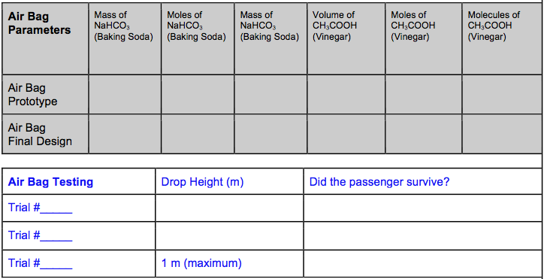

Final Run: When you have completed 3 trials and are confident in your design, notify Mrs. Slavens that you are ready for your final run. You will run your final run completely in front of Mrs. Slavens starting from scratch.

Did your egg survive? ________________________

