TITRATION OF A HYDROCHLORIC ACID SOLUTION WITH A SODIUM HYDROXIDE SOLUTION
Purpose: The purpose of this lab is to determine the concentration of a hydrochloric acid solution using acid-base titration.
Background: Titration is a technique that chemists use to determine the unknown concentration of a known solution (we know what chemical is dissolved, but not how much in a solution). Because we know what the chemical is, we know how it will react with other chemicals and we can use that reaction to determine the concentration of the solution by measuring the formation of product(s). In the case of an unknown concentration of acid, we can use a known concentration of hydroxide base. This type of reaction is a neutralization reaction, where salt and water are products of the reaction:
Acid + Base  Salt + H2O
We can use a pH indicator, a chemical that changes color depending on the pH, to show us when the reaction has completely neutralized. This point, where all acid was consumed and there is no excess of base, is called the equivalence point. We can use this equivalence point to determine the initial concentration of acid using a series of calculations. The goal of the titration is to get as close as possible to the equivalence point by careful addition of the base; this will ensure the calculated acid concentration is as close to the true value as possible. You will do three titrations and average the trials.
The terms below will help you understand the terminology used throughout the experiment:
- Titrant—the solution of known concentration, in this lab, the titrant is sodium hydroxide.
- Buret—a long, cylindrical piece of glass that can be used to determine small, accurate quantities of a solution. A buret is controlled by a stopcock, a white Teflon piece that can be turned to deliver the solution. The markings on the buret are such that you must subtract the initial reading (where the titrant level is initially) from the final reading to determine the volume of base delivered. The buret measures 2 digits after the decimal point accurately.
- Volumetric pipette/pipette bulb—a thin glass tube with only one marking used to measure a very specific volume of liquid. You will use a pipette bulb to pull the liquid into the pipette.
- Phenolphthalein—a pH indicator. In acidic and neutral solutions, the indicator is colorless, but in a basic solution, the color is a vibrant pink. The high the pH is, the stronger the pink color is. The equivalence point will be when the color is a very faint pink color. Keep your flask with acid and indicator over a white piece of paper to ensure you can see the color change.
Materials:
- 50-mL Buret with clamp
- Phenolphthalein indicator
- (3) 250-mL Erlenmeyer flasks
- Small funnel
- 250-mL beaker
- 25-mL volumetric pipette
- Pipette bulb

Also of importance in titrations are the calculations you need to determine the unknown concentration of the acid. These calculations are outlined below. You may want to refer to your notes from lecture for additional examples.
• Determination of moles of base delivered: After each titration, you will need to determine the number of moles of sodium hydroxide used. First, you will need to know the molarity of the solution (the solution has been previously standardized, meaning it has a very accurate molarity that has been experimentally determined). Write this down when you start the titration. Next, you must determine the volume of the solution delivered to reach the equivalence point. Next, you will find the moles of base used in the titration:
*Note that the volume of base is in L, not in mL Determine number of moles of HCl in flask: If you write the balanced reaction for the neutralization of sodium hydroxide and hydrochloric acid, you will see that the reaction proceeds in a 1:1 fashion. That is, for every hydroxide (OH-) ion added, it can neutralize exactly one hydronium (H+) ion. This is not always the case for neutralization reactions, and is thus not always the case for acid-base titrations. The general formula is below, where the determined moles of base from the equation above are multiplied by the stoichiometric ratio found by looking at the balanced equation:
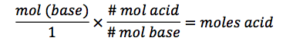
• Determination of acid concentration: Now that you know the number of moles of acid in the flask (at the start of the titration, by the end, there is only water and salt), you can determine its initial concentration. Because you know the initial volume of acid used, you can use the following to determine the concentration:
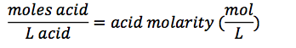
Procedure: You will do three titrations. If you add too much base and the solution is too bright pink, you will need to discard the data and do another run (4 columns of data are provided for this purpose). Patience in this lab will prevent you from having to do extra trials!!!
- Record the molarity of the sodium hydroxide solution on the data sheet
- Obtain about 100 mL of the sodium hydroxide solution in a clean beaker. This should be enough for your first 3 trials and for the initial cleaning of your buret.
- Clean your buret: Add about 5 mL of the base solution from the beaker to the buret (use a funnel to pour). Move the funnel around while adding to ensure the sides of the buret are coated with base. Drain the solution through the stopcock into a waste beaker. Repeat this rinse with a second 5 mL portion of base.
- Pour more of the sodium hydroxide solution into the buret until it is near the 50 mL mark. Open the stopcock to allow several drops to rinse through the tip of the buret. This will eliminate any air bubbles in the buret tip. Record your initial buret reading on the data sheet for trial 1 (the volume does not need to be 0.00 mL).
- Pull 25 mL of the acid solution into the volumetric pipette and transfer into an Erlenmeyer flask. Add 2-3 drops of phenolphthalein to the acid solution in the Erlenmeyer flask.
- Place the flask under the buret and start adding the base solution to the Erlenmeyer flask. Have one lab partner swirl the flask while the other controls the stopcock. When pink starts to develop, add the solution more slowly. At this point you should add one drop at a time followed by swirling until a very light pink color persists. Remember, the lighter the pink the better!!!
- Record the final reading of the buret. Wash the contents of the flask down the drain with water.
- Refill the buret with more sodium hydroxide solution. Record the new volume under trial 2 on the data sheet. Get another sample of acid and add the phenolphthalein as before and repeat the titration 2 more times.
- Fill in the data sheet and post-lab questions. Show your work for full credit!!!

TITRATION OF AN ACID WITH A BASE PRE-LAB
*Show all of your work for full credit
- How will you know when your titration is finished? __________________________________________________________ ___________________________________________________________
- Label the pH scale below with acid, base, and neutral, indicating numbers for each.

- On the scale above, use an arrow to show where your equivalence point is located.
- Show the neutralization reaction that occurs between hydrobromic acid (HBr) and lithium hydroxide (LiOH).

- What is the concentration of 10.00 mL of HBr if it takes 5 mL of a 0.253 M LiOH solution to neutralize it?

TITRATION OF AN ACID WITH A BASE DATA SHEET
*Attach all of your calculations for full credit
Concentration of sodium hydroxide: __________________M
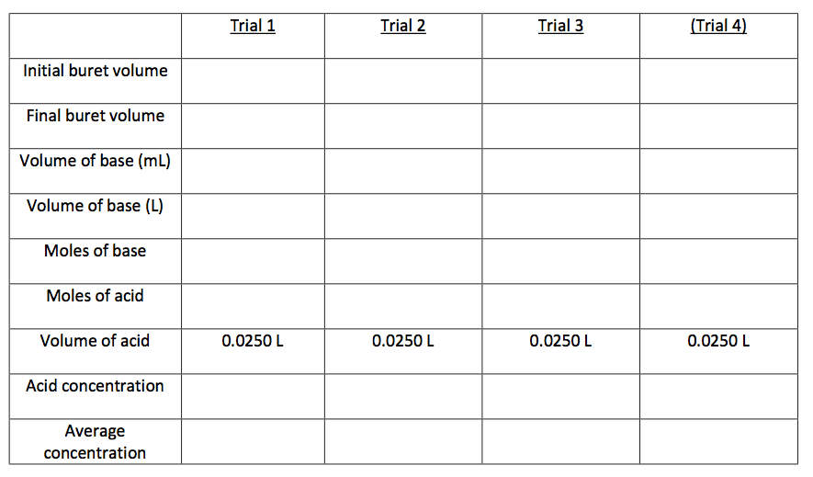Questions:
1. How would it affect your results if you used a beaker with residual water in it to measure out your standardized sodium hydroxide solution? ________________________________________________________________ ________________________________________________________________________________________________________________________________
2. How would it affect your results if you used a wet Erlenmeyer flask instead of a dry one when transferring your acid solution from the volumetric pipette? ________________________________________________________________________________________________________________________________ ________________________________________________________________
3. How do you tell if you have exceeded the equivalence point in your titration? ________________________________________________________________ ________________________________________________________________
4. Vinegar is a solution of acetic acid (CH3COOH) in water. For quality control purposes, it can be titrated using sodium hydroxide to assure a specific % composition. If 25.00 mL of acetic acid is titrated with 9.08 mL of a standardized 2.293 M sodium hydroxide solution, what is the molarity of the vinegar? What is the % composition (wt/wt%)?

Vinegar molarity: ____________________________

Vinegar % composition: _______________________

